
NATIONAL INSTITUTE OF TECHNOLOGY PUDUCHERRY

(An Institution of National Importance under MoE, Govt. of India)
KARAIKAL – 609 609

DEPARTMENT OF COMPUTER SCIENCE AND ENGINEERING

Roll Number: CS22B1038 Name: NIRMAL SASEENDRAN
Semester: 6nd semester Class: CSE
Subject Code: CS1702 Subject Name: NETWORK SECURITY

Assignment - 1 Date: 21-04-2025
RSA Algorithm Implementation

Introduction
RSA (Rivest–Shamir–Adleman) is one of the first public-key cryptosystems and is widely used for secure data transmission. It is based on the mathematical fact that it is easy to multiply large prime numbers but difficult to factor their product.
This report provides a concise overview and a working implementation of RSA using Python, structured entirely with functions to encapsulate key generation, encryption, and decryption processes.

Working of RSA
Key Generation
- Choose two distinct prime numbers p and q.
- Compute n = p * q (used as the modulus).
- Compute Euler's totient function: φ(n) = (p - 1)(q - 1).
- Choose a public exponent e such that 1 < e < φ(n) and gcd(e, φ(n)) = 1.
- Compute the private exponent d, which is the modular inverse of e modulo φ(n).
Encryption
- The plaintext is converted to an integer m.
- The ciphertext c is computed as:
c ≡ m^e mod n

Decryption
- The ciphertext c is decrypted using the private key d:
m ≡ c^d mod n
- The original message is recovered from m.

Python Functions
- generate_prime(): Generates random prime numbers.
- gcd(): Computes the greatest common divisor.
- modinv(): Computes the modular inverse.
- generate_keys(): Generates a pair of public and private keys.
- encrypt(): Encrypts a plaintext string into a list of integers.
- decrypt(): Decrypts a list of integers back into plaintext.

Implementation Code
import random

# Function to compute greatest common divisor
def gcd(a, b):
while b:
a, b = b, a % b
return a

# Function to compute modular inverse using Extended Euclidean Algorithm
def modinv(a, m):
m0, x0, x1 = m, 0, 1
while a > 1:
q = a // m
a, m = m, a % m
x0, x1 = x1 - q * x0, x0
return x1 + m0 if x1 < 0 else x1

# Function to test for primality
def is_prime(n):
if n <= 1:
return False
for i in range(2, int(n ** 0.5) + 1):
if n % i == 0:
return False
return True

# Function to generate a random prime number
def generate_prime(start=100, end=300):
while True:
num = random.randint(start, end)
if is_prime(num):
return num

# Function to generate RSA key pairs
def generate_keys():
p = generate_prime()
q = generate_prime()
while q == p:
q = generate_prime()

n = p * q
phi = (p - 1) * (q - 1)

e = random.randrange(2, phi)
while gcd(e, phi) != 1:
e = random.randrange(2, phi)

d = modinv(e, phi)

return (e, n), (d, n)

# Function to encrypt a message
def encrypt(message, public_key):
e, n = public_key
cipher = [pow(ord(char), e, n) for char in message]
return cipher

# Function to decrypt a message
def decrypt(ciphertext, private_key):
d, n = private_key
message = ''.join([chr(pow(char, d, n)) for char in ciphertext])
return message

# Main function to test the RSA implementation
def rsa_demo():
public_key, private_key = generate_keys()
message = "HELLO RSA"

print("Original Message:", message)
encrypted_msg = encrypt(message, public_key)
print("Encrypted Message:", encrypted_msg)
decrypted_msg = decrypt(encrypted_msg, private_key)
print("Decrypted Message:", decrypted_msg)

# Run the demo
rsa_demo()

Output

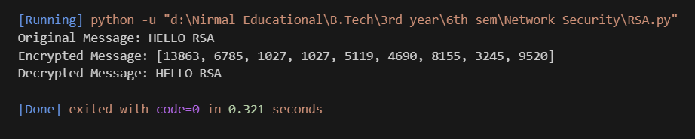

Conclusion
This implementation demonstrates the fundamentals of the RSA cryptosystem using Python functions. While suitable for educational purposes, real-world cryptography relies on very large key sizes (typically 2048+ bits) and secure libraries to handle padding, timing attacks, and other practical security concern.

